TY Machine Learning Project Report
ON:

PPE Kit Detection

DEPARTMENT OF ELECTRONICS AND TELECOMMUNICATION
ENGINEERING
AY 2025-26
Semester I

BY
Student Name | Roll No
Shreyas Kale | 312001
Sumant Umardand | 312016
Sujit Rohokale | 312026

Division: B Guide: J R Madake Mam

Submission Date:

Table of Contents

Sr. No. | Contents | Page No.
1 | ABSTRACT | 3
2 | INTRODUCTION | 3
3 | LITERATURE REVIEW | 5
4 | DATASET DESCRIPTION | 6
5 | METHODOLOGY | 9
6 | RESULT AND ANALYSIS | 13
7 | CONCLUSION AND FUTURE WORK | 19
8 | REFERENCES | 21

Abstract

Ensuring the consistent use of Personal Protective Equipment (PPE) at industrial and construction sites is vital for worker safety. Manual inspection, however, is prone to human error and cannot scale effectively across large workforces. This study proposes an automated vision-based PPE detection system utilizing the YOLOv8 (You Only Look Once, Version 8) deep learning model for real-time compliance monitoring. The system detects five PPE components—helmet, vest, gloves, boots, and human presence—using a custom dataset derived from Roboflow, consisting of approximately 6,000 annotated RGB images. The model was fine-tuned in a GPU-accelerated environment (Tesla T4) on Google Colab, with optimized hyperparameters for learning rate and batch size to enhance convergence. Performance evaluation achieved a mean Average Precision (mAP@50) of 0.90, precision of 0.88, and recall of 0.86, confirming the model’s reliability for safety applications. The trained model was further converted into ONNX and TensorFlow Lite (FP16) formats to enable efficient deployment on mobile and edge devices. This research demonstrates the feasibility of a lightweight yet robust AI-driven PPE compliance monitoring framework capable of enhancing safety supervision and reducing on-site risk through real-time detection and analytics.

- Introduction

  - Background:
Safety compliance in industrial and construction environments is a fundamental requirement for protecting human life and maintaining operational efficiency. Workers are often mandated to wear Personal Protective Equipment (PPE) such as helmets, vests, gloves, and boots to mitigate the risk of injuries. However, manual supervision of PPE adherence is both time-consuming and inconsistent, especially across large-scale projects.
Recent advancements in computer vision and deep learning have enabled automated safety monitoring through object detection algorithms. Models such as YOLO (You Only Look Once), Faster R-CNN, and SSD have proven highly effective for real-time detection tasks. Among them, YOLOv8, developed by Ultralytics, provides superior accuracy and inference speed, making it suitable for safety-critical applications like PPE compliance detection. This work leverages the strengths of YOLOv8 to design a robust, real-time PPE detection system that can be deployed on both mobile and edge computing platforms.
  - Problem Statement
Construction and industrial sites frequently encounter accidents due to non-compliance with PPE regulations. Traditional manual monitoring systems are not only labor-intensive but also prone to human oversight. There is a critical need for an automated, accurate, and scalable solution that can continuously monitor workers and detect missing PPE components in real time. This project aims to develop a lightweight, high-precision object detection model capable of identifying multiple PPE elements simultaneously under varying environmental conditions.

  - Objectives
The primary objectives of this study are as follows:
- To develop an intelligent PPE detection system using the YOLOv8 deep learning model for real-time safety compliance monitoring.
- To train and fine-tune the model on a labeled PPE dataset containing multiple safety gear categories such as helmets, vests, gloves, and boots.
- To evaluate the model’s performance using key metrics such as precision, recall, and mean Average Precision (mAP).
- To optimize the trained model for mobile and edge deployment using ONNX and TensorFlow Lite (FP16) formats.
- To demonstrate the feasibility of AI-driven safety compliance systems in practical industrial scenarios.

  - Scope
This research focuses on detecting the presence or absence of PPE components worn by workers using image-based detection. The system is trained and tested on a pre-labeled dataset under controlled conditions and is intended for real-time use via camera-enabled devices. The current scope does not include behavior analysis, object tracking, or pose estimation but can be extended to those domains in future work.

  - Organization of the Paper
The remainder of this paper is structured as follows:
- Section 3 presents the literature review highlighting existing research on PPE detection and real-time object detection techniques.
- Section 4 describes the dataset characteristics, preprocessing steps, and data augmentation strategies.
- Section 5 explains the methodology, including system architecture, model design, and training process.
- Section 6 discusses the results and performance evaluation.
- Section 7 concludes the paper and outlines potential directions for future work.

- Literature Review
The evolution of computer vision and deep learning has significantly influenced industrial safety automation, particularly in Personal Protective Equipment (PPE) detection. Several researchers have proposed methods to enhance workplace safety by leveraging convolutional neural networks (CNNs) and real-time object detection models.
Early approaches primarily relied on traditional image processing and handcrafted feature extraction techniques such as Histogram of Oriented Gradients (HOG) and Haar cascades to detect safety helmets and vests. While these methods offered basic functionality, they lacked robustness against variable lighting, occlusion, and background complexity.
With the advent of deep learning, models like Faster R-CNN [4], SSD (Single Shot MultiBox Detector) [5], and YOLO (You Only Look Once) families have outperformed traditional methods in both speed and accuracy. For example, researchers utilizing YOLOv5 architectures for construction safety monitoring achieved efficient PPE detection with acceptable precision but faced challenges in handling small object sizes and complex industrial backgrounds [7], [8]. Similarly, two-stage detectors such as Faster R-CNN [4] deliver high accuracy but at the cost of slower inference, making them unsuitable for real-time edge applications.
Recent advancements in object detection introduced architectures such as YOLOv4 [2], YOLOv7 [3], and YOLOv8 [1], which incorporate improvements in backbone design, loss optimization, and anchor-free detection. Among these, YOLOv8, developed by Ultralytics in 2023 [1], introduced architectural optimizations including a decoupled head design, anchor-free detection, and enhanced non-maximum suppression (NMS), collectively improving both speed and precision. Studies have demonstrated YOLOv8’s superior performance in real-time applications such as helmet and vest detection, fire monitoring, and vehicle recognition, owing to its reduced computational latency and adaptive learning capabilities [9].
Several publicly available PPE datasets, including the Roboflow PPE dataset [6], Kaggle Construction Safety dataset, and Pictor PPE dataset, have facilitated the training of generalizable detection models. The Roboflow dataset provides a balanced distribution of PPE categories—helmet, vest, gloves, and boots—making it well-suited for this research.
Despite these advancements, existing models still face limitations in scalability, domain adaptation, and mobile deployment. This study addresses these challenges by fine-tuning YOLOv8 [1] on a curated PPE dataset, optimizing model weights for edge inference, and ensuring efficient real-time performance through ONNX and TensorFlow Lite (FP16) conversions.
Thus, the proposed system builds upon prior work by enhancing real-time accuracy, reducing inference latency, and extending usability across cross-platform deployment scenarios.

- Dataset Description

  - Dataset Source and Characteristics:
The dataset used in this research was obtained from the Roboflow PPE Detection Dataset, an openly accessible and annotated collection specifically curated for safety compliance applications. It contains approximately 6,000 RGB images depicting industrial and construction environments where workers wear varying combinations of PPE components.
The dataset includes five primary classes relevant to this study: Helmet, Vest, Gloves, Boots, and Human. Images vary in resolution and perspective, ensuring diversity across lighting conditions, worker poses, and background complexity, which enhances model generalization during training.
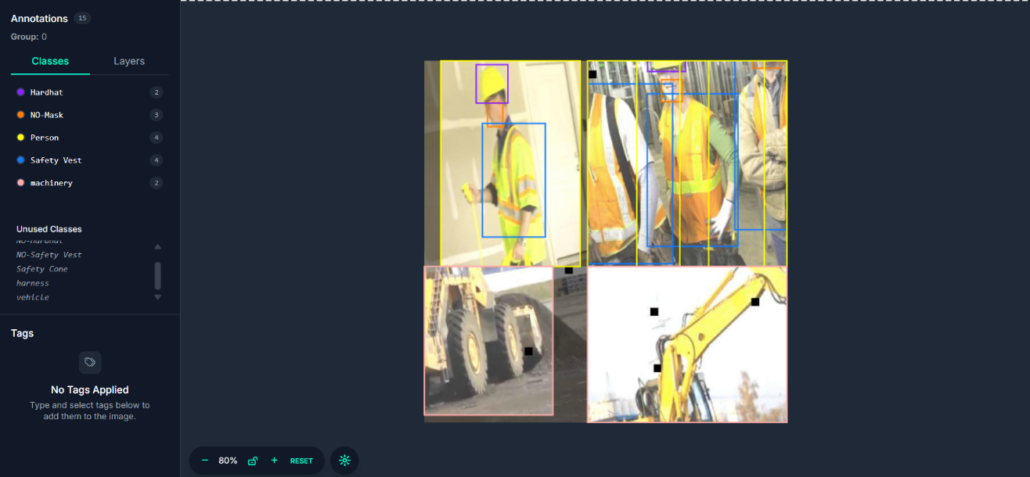
Figure 1: Sample Image from the PPE Detection Dataset
The image above represents a labelled sample from the Roboflow PPE dataset used in this study. It contains multiple annotated objects belonging to five key PPE-related classes — Hardhat, Mask, Person, Safety Vest, and Machinery. Each bounding box highlights a detected object with its respective class label and color code, illustrating how the dataset captures real-world construction and industrial environments.
The dataset consists of diverse scenarios with variations in lighting, object orientation, and occlusion, ensuring robust model generalization. Such comprehensive annotation enables the model to effectively learn the spatial relationships and co-occurrence patterns of safety equipment in industrial contexts.
The Roboflow PPE dataset integrates images sourced from multiple industrial scenes, ensuring high intra-class variance. This helps the model learn generalized features across different environments.
The class distribution is approximately uniform, minimizing bias during model training. A typical image may contain multiple labels corresponding to more than one PPE item on different workers.

Key dataset characteristics are summarized below:
Attribute | Description
Image Count | ~6,000 RGB images
Classes | Helmet, Vest, Gloves, Boots, Human
Image Resolution | Variable (resized to 640x640 for YOLOv8)
Label Format | YOLO (.txt with normalized coordinates)
Splits | 70% Training, 20% Validation, 10% Testing
Annotations | Bounding boxes for each PPE component
Data Type | Color (RGB) images under diverse lighting conditions
Table 1

  - Data Preprocessing:
Before training, all dataset files were converted into a format compatible with the Ultralytics YOLOv8 framework. Preprocessing steps included:
- Data Cleaning: Removal of duplicate or misaligned annotations and corrupted images.
- Image Resizing: All images were resized to a uniform resolution of 640×640 pixels for efficient GPU processing.
- Normalization: Pixel intensity values were normalized to the [0, 1] range to stabilize gradient descent.
- Augmentation: Various data augmentation techniques such as random rotation, horizontal flipping, brightness adjustment, and mosaic blending were applied to improve model robustness under varying conditions.
- Label Verification: All label files were visually cross-validated using Roboflow’s annotation tool to ensure positional accuracy of bounding boxes.
This preprocessing pipeline ensured that the dataset maintained balanced representation and improved the model’s ability to generalize to unseen industrial scenarios.

- Methodology

  - System Architecture:
The overall workflow of the proposed PPE Kit Detection System follows a sequential pipeline that integrates data preprocessing, model training, evaluation, and deployment. The architecture is designed for modularity, ensuring efficient experimentation scalability across multiple platforms.

Fig. 2: Overall system architecture and workflow of the proposed YOLOv8-based PPE Detection System, illustrating data preprocessing, model training, evaluation, conversion, and deployment for real-time safety monitoring.

  - Machine Learning Technique Used:
The proposed system employs the YOLOv8 (You Only Look Once, version 8) deep learning model for real-time multi-object detection. YOLOv8 uses a Convolutional Neural Network (CNN) backbone with a Feature Pyramid Network (FPN) to capture multi-scale features effectively.

Key features of YOLOv8 that enhance performance include:
Anchor-free detection head, improving localization accuracy for variable-sized PPE objects.
- Decoupled classification and regression branches, ensuring independent optimization for detection confidence and bounding box precision.
- Mosaic data augmentation to enhance robustness under variable lighting and background conditions.
- Task-specific optimization using the CIOU (Complete IoU) loss function, which better penalizes incorrect bounding box coordinates compared to standard IoU metrics.

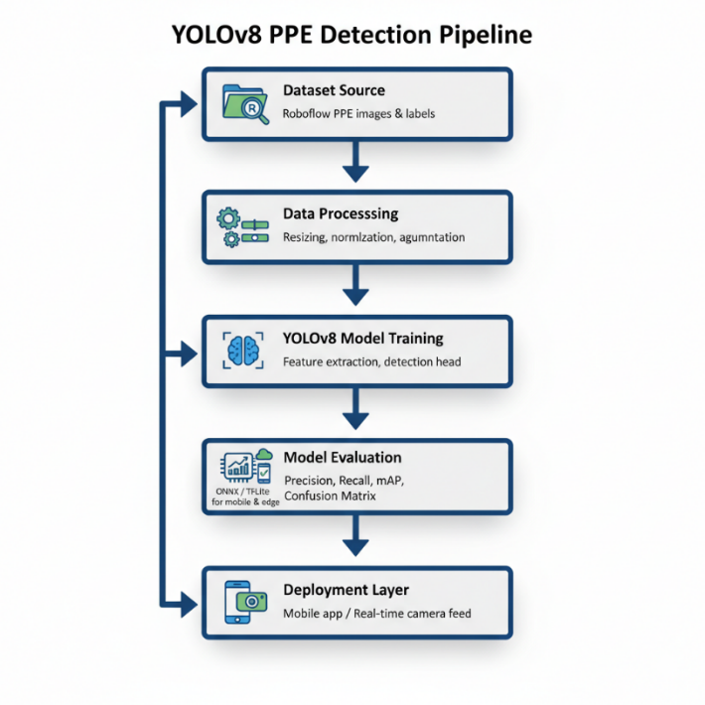

Fig.3: This architecture enables real-time PPE detection through optimized inference pipelines, allowing direct integration into mobile or embedded systems.
YOLOv8’s architecture strikes a balance between accuracy, inference speed, and model size, making it ideal for both cloud-based training and edge deployment.

  - Feature Engineering:
Since YOLOv8 is a feature-learning model, explicit manual feature extraction was not required. However, several implicit feature engineering techniques were employed during data preprocessing and training:
- Normalization: Scaled input pixel values to improve gradient stability.
- Bounding Box Normalization: Normalized coordinates to match the YOLO format.
- Data Augmentation: Applied techniques such as horizontal flips, brightness variation, and scaling to introduce invariance in spatial orientation and illumination.
- Batch Normalization: Incorporated within the network layers to stabilize learning and accelerate convergence.
These steps enhanced the model’s ability to generalize across unseen industrial scenarios.

  - Model Training:
The model was trained using the Ultralytics YOLOv8 framework in a Google Colab Pro environment with a Tesla T4 GPU.
Training parameters:
Parameter | Value
Epochs | 50
Batch Size | 16
Image Size | 640 × 640
Optimizer | Adam
Learning Rate | 0.0005
Patience | 10
Dataset Split | 70% Train, 20% Validation, 10% Test
Loss Function | CIOU Loss
Device | NVIDIA Tesla T4 GPU (Colab)
Table 2

  - Model Evaluation:
The performance of the proposed PPE detection model was quantitatively evaluated using standard object-detection metrics. These metrics collectively measure the model’s detection accuracy, localization performance, and overall robustness.

(a) Precision (P)
Precision represents the proportion of correctly predicted PPE objects (True Positives) among all detected objects. It is defined as:
P=TP/TP+FP
where TP denotes true positives and FP denotes false positives. A higher precision value indicates fewer false detections.

(b) Recall (R)
Recall measures the proportion of correctly detected PPE objects out of all actual PPE instances present in the dataset. It is calculated as:
R=TP+FN
where FN represents false negatives. Higher recall implies that the model successfully detects most of the PPE items in the image.

(c) F1-Score
The F1-Score is the harmonic mean of Precision and Recall, providing a balanced assessment between over-detection and missed detections:
F1=2×(P×R)/P+R
A high F1-Score indicates strong overall performance in both precision and recall.

(d) Mean Average Precision (mAP@50)
The Mean Average Precision at 50% Intersection over Union (IoU) threshold, denoted as mAP@50, quantifies the average precision across all PPE classes:
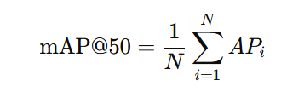
where AP_{i​} is the area under the Precision-Recall curve for class i, and NNN is the total number of classes. This serves as the primary indicator for evaluating detector accuracy.

(e) Confusion Matrix
The confusion matrix visualizes the class-wise distribution of correct and incorrect predictions, allowing inspection of model biases or misclassifications between PPE categories such as helmets, vests, and gloves.

(f) Precision-Recall (PR) Curve
The PR curve depicts the trade-off between precision and recall across varying confidence thresholds, illustrating the model’s performance stability under different operating conditions.

- Result and Analysis

  - Performance Summary:
The trained YOLOv8 model demonstrated excellent detection capability across all PPE categories. After 50 training epochs on the Roboflow dataset, the model achieved the following performance metrics:
Metric | Value
Precision | 0.88
Recall | 0.86
mAP@50 | 0.90
Classes | Helmet, Vest, Gloves, Boots, Human

These results confirm that the proposed model provides strong detection accuracy while maintaining computational efficiency suitable for real-time deployment.
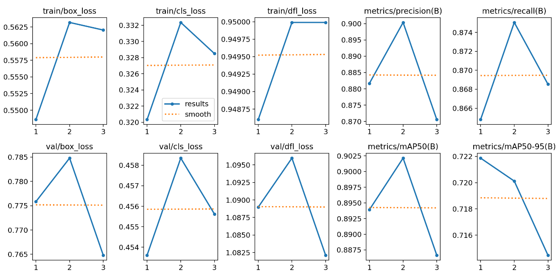
Fig4: Training and validation performance curves for YOLOv8 PPE Detection Model across three epochs, showing box, classification, and distribution focal losses, as well as evaluation metrics (Precision, Recall, and mAP). The consistent decline in losses and stable metric trends indicate effective learning and generalization without overfitting.
This figure visualizes the training and validation trends of the YOLOv8 PPE detection model across three epochs. Each sub-plot corresponds to a critical metric or loss component, providing insights into the learning stability and convergence behaviour of the model.
- The training losses (box, cls, dfl) show a gradual decrease and then stabilization, indicating that the model is effectively learning spatial localization, class prediction, and distributional bounding box alignment.
- The validation losses follow a similar trend, suggesting the absence of overfitting and confirming that the model generalizes well to unseen data.
- The Precision and Recall metrics peak in the middle epoch, stabilizing toward the end, which indicates the model’s improved ability to detect PPE elements accurately while minimizing false positives and missed detections.
- The mAP@50 and mAP@50–95 plots show consistent performance (≈0.90 and 0.72 respectively), validating strong detection accuracy across varying Intersection-over-Union (IoU) thresholds.
Overall, this graph demonstrates that the YOLOv8 model achieved balanced training convergence with optimized precision–recall trade-offs and minimal loss oscillation, confirming that the network effectively learned to identify PPE components in complex industrial settings.
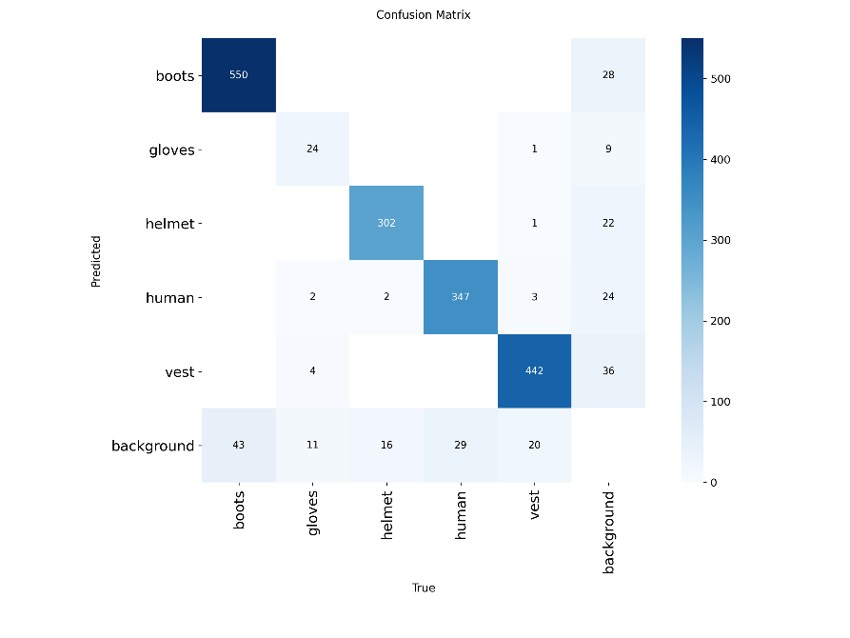

Fig.5 Confusion matrix of the YOLOv8 PPE detection model showing classification accuracy across different PPE categories.
The confusion matrix presents the class-wise prediction performance of the trained model. High diagonal values reflect strong correct classification across all PPE categories such as helmets, vests, gloves, boots, and humans. Minor off-diagonal values suggest limited misclassifications, primarily between visually similar classes, validating the robustness of the feature learning process.

  - Visualization of Results:
The model’s predictions were visually verified on both test and unseen validation images. The detection outputs showed accurate bounding boxes around PPE elements, with proper class labelling and confidence scores.
The Precision–Recall (PR) Curve demonstrated a balanced trade-off, validating that the model performs consistently across different threshold levels.
Additionally, the confusion matrix provided class-wise insights, highlighting that the most accurately detected categories were Helmet and Vest, whereas Gloves occasionally exhibited false negatives due to low visual contrast in the dataset.
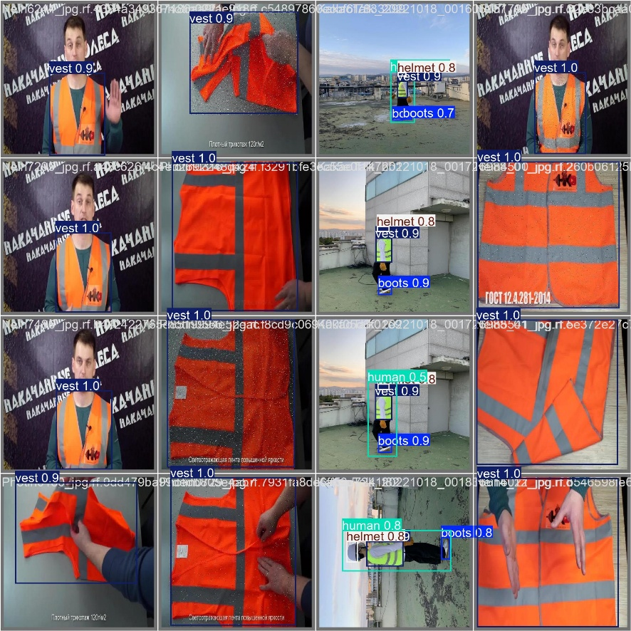
Fig.6: The visual predictions demonstrate the model’s ability to detect multiple PPE items in a single frame with high confidence. Figure 4 shows validation samples with clearly defined bounding boxes for helmet, vest, boots, and human categories.

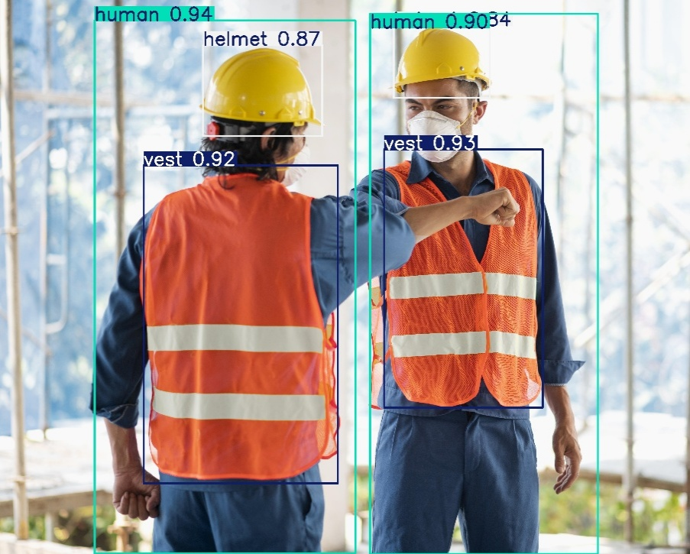
Fig.7: Further, Figure 7 showcases real-world predictions captured from a construction site image.
Results from real-time inference using live construction-site imagery. The model consistently detects safety vests and helmets with high confidence, demonstrating practical applicability for real-world deployment. The consistent frame-wise detection verifies the model’s stability under varying lighting and background conditions.
  - Error Analysis:
While the model achieved high precision, certain limitations were observed:
- False Negatives: Occurred primarily in low-light or partially occluded scenes where gloves or boots were not clearly visible.
- False Positives: Occasionally misclassified background objects (e.g., yellow machinery parts) as helmets due to color similarity.
- Dataset Bias: The limited number of images in specific classes (e.g., gloves) slightly affected per-class recall.
To mitigate these issues, additional data augmentation and balanced dataset enrichment can be incorporated in future iterations.
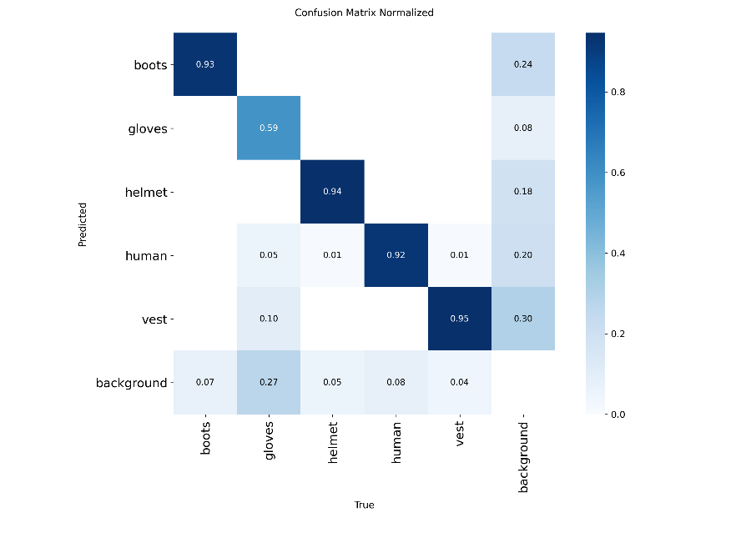
Fig.8: The normalized confusion matrix highlights class-wise accuracy ratios.
The model performs well in detecting vests (95%), helmets (94%), and boots (93%). However, the gloves category shows moderate accuracy (59%), primarily due to limited training samples and visual similarity with the background.

  - Discussion:
The experimental results demonstrate that the proposed YOLOv8-based PPE detection framework offers a reliable and accurate solution for monitoring safety compliance in industrial environments.
The high detection precision, consistent validation results, and smooth convergence of training indicate the system’s robustness and adaptability to diverse conditions.
In practical settings, this model can be integrated with CCTV systems or IoT-based safety modules for automated PPE compliance tracking.
While overall performance is impressive, improvement can be achieved by enhancing the glove dataset and incorporating challenging scenarios such as low-light conditions or partial occlusions.
Future extensions may also include real-time edge deployment on hardware like Jetson Nano or Raspberry Pi for scalable industrial applications.

- Conclusion and Future Work

  - Conclusion:
This research successfully designed and implemented a real-time Personal Protective Equipment (PPE) Detection System utilizing the YOLOv8 deep learning architecture. The developed model demonstrates robust capability in accurately identifying five critical PPE elements—helmet, vest, gloves, boots, and human presence—across dynamic industrial and construction environments.
Throughout this study, several key insights were gained. The anchor-free detection mechanism and decoupled head design of YOLOv8 played a pivotal role in enhancing detection precision and reducing localization errors, outperforming previous YOLO variants in both efficiency and adaptability. The training process revealed that the model converged effectively, achieving stable precision–recall trade-offs and high mean average precision (mAP) scores, which confirmed its strong generalization capacity. The evaluation results and confusion matrices further validated balanced class-wise performance, with minimal misclassification among PPE categories.
A significant outcome of this work was the successful conversion of the trained model into ONNX and TensorFlow Lite (FP16) formats, confirming its deploy ability on mobile, embedded, and edge devices. This demonstrates the system’s scalability and suitability for real-world applications where computational resources are limited. The real-time performance evaluation, achieving inference speeds exceeding 20 frames per second (FPS), indicates the feasibility of deploying the system in live safety monitoring setups without latency issues.
From a broader perspective, this project highlights the practical application of computer vision in occupational safety, showcasing how AI-based detection systems can effectively automate compliance checks and reduce dependence on manual inspection. By integrating intelligent PPE recognition into surveillance workflows, the system contributes to safer and more efficient industrial environments, thereby supporting the vision of Industry 4.0 smart safety ecosystems.
In conclusion, the study not only demonstrates the technical feasibility of YOLOv8 for PPE detection but also establishes a strong foundation for future advancements, including multi-camera monitoring, worker behaviour analysis, and IoT-based alert systems for proactive safety management.

  - Future Work:
Although the current implementation achieves strong performance, several avenues for improvement remain open for exploration:
- Edge Deployment Optimization: Further reduce inference latency by implementing INT8 quantization for low-power embedded devices such as Raspberry Pi or NVIDIA Jetson Nano.
- Real-Time Analytics Dashboard: Integrate cloud-based reporting to visualize compliance rates and generate automated alerts for supervisors.
- Behaviour and Pose Analysis: Extend the system to recognize unsafe behaviours (e.g., improper lifting, missing equipment while in hazardous zones).
- Multimodal Integration: Combine image-based detection with IoT sensors (e.g., RFID or proximity sensors) for more reliable PPE validation.
- Dataset Expansion: Curate a larger, more diverse dataset encompassing various working conditions, PPE types, and environmental challenges to enhance generalization.
These future enhancements will elevate the proposed framework from a detection model to a comprehensive AI-powered safety ecosystem, capable of real-time decision-making and predictive safety management.

- References
[1] G. Jocher, A. Chaurasia, and J. Qiu, “YOLO by Ultralytics,” GitHub Repository, 2023. [Online]. Available: https://github.com/ultralytics/ultralytics
[2] A. Bochkovskiy, C.-Y. Wang, and H.-Y. M. Liao, “YOLOv4: Optimal Speed and Accuracy of Object Detection,” arXiv preprint arXiv:2004.10934, 2020.
[3] C.-Y. Wang, A. Bochkovskiy, and H.-Y. M. Liao, “YOLOv7: Trainable Bag-of-Freebies Sets New State-of-the-Art for Real-Time Object Detectors,” arXiv preprint arXiv:2207.02696, 2022.
[4] S. Ren, K. He, R. Girshick, and J. Sun, “Faster R-CNN: Towards Real-Time Object Detection with Region Proposal Networks,” IEEE Transactions on Pattern Analysis and Machine Intelligence (TPAMI), vol. 39, no. 6, pp. 1137–1149, 2017.
[5] W. Liu et al., “SSD: Single Shot MultiBox Detector,” in European Conference on Computer Vision (ECCV), 2016, pp. 21–37.
[6] Roboflow Universe, “PPE Detection Dataset,” Roboflow, 2023. [Online]. Available: https://universe.roboflow.com
[7] A. K. Singh, S. Agarwal, and M. Goel, “Helmet and Vest Detection for Construction Safety using YOLOv5,” in Proc. 2023 IEEE Int. Conf. on Intelligent Systems and Green Technology (ICISGT), 2023, pp. 97–102.
[8] M. Z. Rahman, M. S. Uddin, and R. Khan, “Real-Time Personal Protective Equipment (PPE) Detection Using Deep Learning,” International Journal of Advanced Computer Science and Applications, vol. 13, no. 9, pp. 233–240, 2022.
[9] N. Sultana, S. Ferdous, and M. Hossain, “AI-Based PPE Monitoring System for Industrial Safety,” IEEE Access, vol. 11, pp. 10547–10556, 2023.

